**UNIVERSITY OF DAR ES SALAAM**



**COLLEGE OF INFORMATION AND COMMUNICATION TECHNOLOGIES**

**(COICT)**

**DEPARTMENT OF ELECTRONICS AND TELECOMMUNICATIONS ENGINEERING**

**PROJECT PROGRESSIVE REPORT**

**A Project Report in Partial Fulfillment for the Award of Bachelor of Science in Telecommunications Engineering**

**PROJECT TITLE**: DESIGN AND IMPLEMENTATION OF CoICT DRONE MESSENGER

**STUDENT NAME**: NYAKUNGA, Julio C

**REGISTRATION NO**: 2015-04-02515

**DEGREE PROGRAM**: Bachelor of Science in Telecommunications Engineering

**PROJECT SUPERVISOR**: CHRISTINE MWASE

…………………………….. ………………………...

(Project supervisor signature) (Student signature)

# ABSTRACT

Drones, also known as unmanned aerial vehicle (UAVs) are now rapidly becoming valuable tool in variety of industries due to it mobility and capability to function as other vehicles do. So, it is need to improve them and optimize them so that they suit to help simplify human life.

As in any community people need to share different things, to make this sharing possible one has to move from one location to another to deliver that material or to take it, this is time consuming as one moves from one place to another. In the UDSM CoICT campus students need to share material things such as flash disks, exercise book, keys and even letters and moving from one location to another is time consuming and there is needed a way to take make this sharing simpler.

A solution to this is to have the system that will enable students to safely share material things without them to move. My proposed solution to this is to have the drone that will carry materials from one location to another within the campus.

In this second semester of academic year 2018/2019 I have been building the drone as the continuation of the design that I did on the first semester of this academic year.

Table of Contents

ABSTRACT i

LIST OF FIGURES iii

INTRODUCTION 1

PROBLEM STATEMENT 1

OBJECTIVES OF THE PROJECT 1

LITERATURE REVIEW 2

EXISTING SOLUTION 4

PROPOSED SOLUTION 4

METHODOLOGY 5

CONSULTATION 5

LITERATURE REVIEW 5

REQUREMENT CAPTURE AND ANALYSIS 5

CIRCUIT DESIGN 5

CIRCUIT SIMULATION 6

CIRCUIT IMPLEMENTATION 6

REQUIREMENT ANALYSIS AND SPECIFICATIONS 7

SYSTEM REQUIREMENTS 7

DRONE SYSTEM HARWARE SPECIFICATIONS 7

Drone frame 7

Propulsion subsystem 7

Communication subsystem 8

Sensors 8

Drone flight controller 9

Power supply 9

DRONE FRAME DESING DIAGRAM 9

DRONE CIRCUIT DIAGRAM 10

DRONE BUILDING 11

DRONE FRAME BUILDING 11

DRONE FLIGHT CONROLLER CIRCUIT BUILDING 13

SOLDERING ATMega328P MICROCONTROLLER HOLDERS (CHIP HOLDERS) 13

SOLDERING MPU6050 (INERTIA MEASUREMENT UNIT, IMU) MODULE 13

DRONE COMMUNICATION SYSTEMS 14

SOLDERING ESP8266 WIFI MODULE 14

CONNECTING GSM/GPS MODULE 14

DRONE SYSTEM POWER SUPPLY 15

MICROCONTROLLER SKETCH BUILDING 17

ADROID APPLICATION DEVELOPMENT 18

WORKDONE SO FAR 20

SUMMARY 23

TIME SCHEDULE 24

BUDGET 25

CONCLUSION, CHALLENGE AND RECOMMENDATION 26

Conclusion 26

Challenges 26

Recommendations 26

REFERENCES 27

# LIST OF FIGURES

Figure 1: Drone carrying a package 4

Figure 2 Drone frame design diagram 9

Figure 3 System circuit diagram 10

Figure 4: drone frame building 12

Figure 5: FRAGMENT 2 FOR SENDING COMMANDS TO THE DRONE 17

Figure 6: FRAGMENT 3 FOR VIEWING DRONE STATUS 18

# INTRODUCTION

This project deals with building the flying drone that will be used by CoICT members to send and receive loads or packages weighing not more than 0.5Kg. The drone will be built with reference to the designing that was done in the first semester of the academic year 2018.2019.

I have built a microcontroller-based circuit to provide the drone flying operations and interpret all the input to the system to provide the desire output.

.

## PROBLEM STATEMENT

In the UDSM CoICT campus members use to share things like letters, flash disks, exercise books and door keys, with other fellow members in the campus due to a lot of activities that one might have it gets them hard to share things and it takes one to live his/her position/location to meet the other person so that they can deliver things to each other. This is the time-consuming activity in the campus.

## OBJECTIVES OF THE PROJECT

**The main objective is:**

To design a flying drone system that will automatically fly from one location to another for delivering material weight not more than 0.5Kg from one CoICT member to another member in the different location in the campus.

**The specific objectives are:**

* To design and implement a four motor drone that can carry 0.5Kg materials
* To design the microcomputer-based system that will provide all the controls to enable the drone to fly.
* To integrate gyro and accelerometer sensors to enable the microcontroller circuit to know the state of the drone.
* To integrate the GSM and WI-FI adapter to the system to provide network connectivity to the drone.
* To develop an android application that that CoICT members will use to interact with the drone and control it which will be an Android application, for example tell it where to take the load to.

# LITERATURE REVIEW

In Tanzania there are no drones that are used for delivering packages still packages are delivered by using trucks. But in the developed countries such as in USA some of the bug companies are now using drones to deliver packages to their customers. In the USA companies like Amazon, Google and DHL and UPS are now using drones to deliver packages instead of trucks. This is real a good idea as it is found that it is the cases that using electric-powered drones rather than diesel-powered trucks or vans could reduce energy use and greenhouse gas emissions and it is time saving way of delivering products.

Drones vary in size depending on the type of load the can carry, and to optimize the carrying capability of the drone the number of motors and propellers used are increased. The most common drone in use is called a quadcopter.

In different parts of the world drone projects have been done that came up with good results that invented the new applications of drone to human life. The following are some of the drone project resulted applications of drones: Photography, Security Surveillance, Search and Rescue, Building Inspections, Agricultural Surveys, Underwater Inspections and Mapping and Surveying.

Types of drone

Drone can be categorized basing on different criteria such are number of propellers, physical appearance and flight mode used.

Below are types of drone basing on number of propellers: single rotor, tricopter, quadcopter, hexacopter and octocopter. Each of the type has its advantages and disadvantages, for example single rotor, tricopter and quadcopter are cost effective due to few number of propeller it uses but have no redundancy of motors to save it when on motor fails as their disadvantage compared to hexacopter and octocopter which have a large number of propellers but they can still keep flying even when one motor fails.

Basing on size drone can be categorized as follows: very small drone, mini drone, medium and large drones.

Basing on aerial platform used in the drone there are following types of drones:

1. Multi rotor drones
2. Fixed wing drones
3. Single rotor drone
4. Fixed wing hybrid drone

Table below shows the different types of droneof drones basing number of propellers used in the drone:

|  |  |  |  |
| --- | --- | --- | --- |
| DRONE TYPE | Number of propellers | Advantages | Disadvantages |
| Tricopter | 3 | * It is cheaper due to few number of propellers. * Easy to make due to few number of propellers. | * When one propeller fails the drone crushes. * Hard to balance thrust generated by the 3 motor (not symmetric). |
| Quadcopter | 4 | * Easy to balance thrust generated by the 4 motor (they are symmetric). | * When one propeller fails the drone crushes |
| Hexacopter | 6 | * Easy to balance thrust generated by the 6 motor (they are symmetric). * It can keep flying safely even when one propeller fails. | * It is expensive due to large number of propellers. |
| Octocopter | 8 | * Easy to balance thrust generated by the 8 motor (they are symmetric). * It can keep flying safely even when one propeller fails. | * It is expensive due to large number of propellers. |

Table 1: Types of drones

## EXISTING SOLUTION

In the college materials are delivered from on point to another by human moving from one point to another, this is the safe solution though it is time consuming for students and staffs in the college.

## PROPOSED SOLUTION

Drone should be used to carry materials from on point to another in the college.

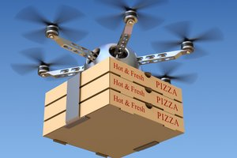

Figure 1: Drone carrying a package

# METHODOLOGY

Below are the steps that I will follow to accomplish my project:

## CONSULTATION

This involves consulting my project supervisor and other people who are familiar with the project. So far, I have done 3 meeting s with my supervisor where we discussed the project and she advised me different things mainly on the design of the system.

## LITERATURE REVIEW

Via literature review I get to learn what other people have done so far to solve the same problem I want to solve and different method and technologies that are currently used. I do this by reading articles and books and browsing the Internet. I think via this technique I can know the weakness of the currently used methods and optimize my design so that I real have that Key features to make people like my solution.

## REQUREMENT CAPTURE AND ANALYSIS

This step involves gathering information required for my system and checking their reliability and relevance. Requirement gathering helped me to know the relevant materials that CoICT members do actually share. So it helped me know the maximum load size that my drone should support to have helped CoICT members to have their material sharing problem solved by using drone.

## CIRCUIT DESIGN

After I have gathered enough requirement for my project, I will start designing the circuit that so

that I have the clear view of how different electronic devices should be integrated so that there will be a well-defined relationship between system inputs and outputs, so that to make an intelligent system that can itself control the drone flying operations.

To automate the system there must be some inputs from the user that dictates/tells the drone of what to do. To make the system intelligent one will have to request the drone and specify the location that it should take the load to or from. So, the main system inputs will be the done request and drone destination location address.

The intelligence of the system will be brought by the microcontroller that I will program it in such a way that I can understand the type of input it receives and provide the right response/output to the requests according to the inputs. I will use Fritzing application to design the system circuit.

## CIRCUIT SIMULATION

After I have designed my circuit, I will make an ideal system that performs with the specified conditions the same thing as my real circuit so that I can impose different conditions to see how the system behaves. I will use the simulation software such as proteus, circuit maker and MATLAB software to simulation my design.

## CIRCUIT IMPLEMENTATION

I will make the actual system after the good results from the design and simulation. I will start by building the subsystem test circuits on the breadboard and test them it after the good result from the test circuit I will then build the complete system circuit on the strip board with wires soldered.

CIRCUIT TESTING

In this part I will be testing the implemented circuit so as I know if my intended design purposes have been reached or not. During testing I will be putting the inputs and see how they are processed and what response my system will give to that specific input.

Materials used:

* Wooden sealing board,
* Bamboo sticks
* 4 plastic 3D printed drone legs/stands

Tools used:

* + Fritzing application to design the system circuit.
  + Arduino IDE to program a microcontroller.
  + Android studio to build an android application
  + Saw,
  + Hammer,
  + Rule and a pencil,
  + Bolts and nuts,
  + Araldite glue,
  + Glue gun,
  + Sol tape
  + Screws and screwdrivers

# REQUIREMENT ANALYSIS AND SPECIFICATIONS

## SYSTEM REQUIREMENTS

1. The drone should be able to carry load of not more than 0.5Kg
2. The drone should be able to fly automatically without manual control by the user.
3. The drone should be able to determine its current location/position.
4. The drone should have network connectivity that users will use to interface with the drone to command it.

## DRONE SYSTEM HARWARE SPECIFICATIONS

My drone system will have 6 main subsystems (functional unit)

1. Drone frame
2. Propulsion subsystem
3. Communication subsystem
4. Sensors
5. Drone flight controller
6. Power supply

### Drone frame

This is the skeleton of the drone, this define size and physical appearance of the drone. It is also depending on the number of propellers used.

### Propulsion subsystem

This subsystem deals with generation of mechanical energy require to lift up the drone. It comprises of the electric speed controller, brushless motors and propellers.

ESC controls the speed of brushless motors. It sits between the power supply and brushless motor. It receives control signals from the microcontroller and generates the PWM signals to the motors.

4 brushless motors will be controlled by 4 ESCs, hence 4 control signal wires will be connected from the Microcontroller circuit to the 4 ESCs.

### Communication subsystem

This subsystem provides network connectivity to the drone. Via the communication units like Wi-Fi module and GSM Module one can interact with the drone so that to command it to go somewhere it is needed to go. Also GPS module will be connected to the system to read the location of the drone.

Wi-Fi module will need a single pair of wires (Two wires), on for transmitting and the other for receiving signals to and from the microcontroller.

The GSM module will need a single pair of wires (Two wires), on for transmitting and the other for receiving signals to and from the microcontroller.

The GPS module will need a single pair of wires (Two wires), on for transmitting and the other for receiving signals to and from the microcontroller. Because I use the module which has both GSM and GPS module integrated together so a single pair of serial port will be used for GSM and GPS communications.

Thus for communication 4 serial ports of the microcontroller will be used.

### Sensors

To enable the drone to fly 4 sensors will be connected to the microcontroller circuit.

1. Accelerometer: this is used to measure linear acceleration of the drone and to detect which side of the drone in down so that the microcontroller can balance the drone.
2. Gyroscope: this is used to measure angular acceleration of the drone and so that microcontroller circuit can turn the drone by an angle.
3. Compass/magnetometer: this is used to determine the drone compass direction.
4. Ultrasonic distance sensor: this is used to measure drone distance from a physical obstacle such as hills, buildings or ground surface.
5. Barometer: this is used to measure air pressure around the drone and height of the drone the ground.

### Drone flight controller

This is the microcontroller circuit that receive the signals from sensors and communication units and generate a desired response to the system.

### Power supply

This is the power supply of the system. This supplied energy to the system to power on the motors and microcontroller circuit. For this drone a 4S LIPo battery has been used.

# DRONE FRAME DESING DIAGRAM

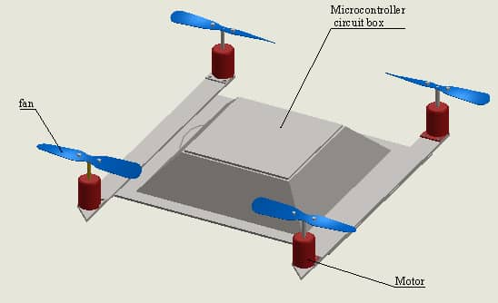

Figure 2 Drone frame design diagram

# DRONE CIRCUIT DIAGRAM

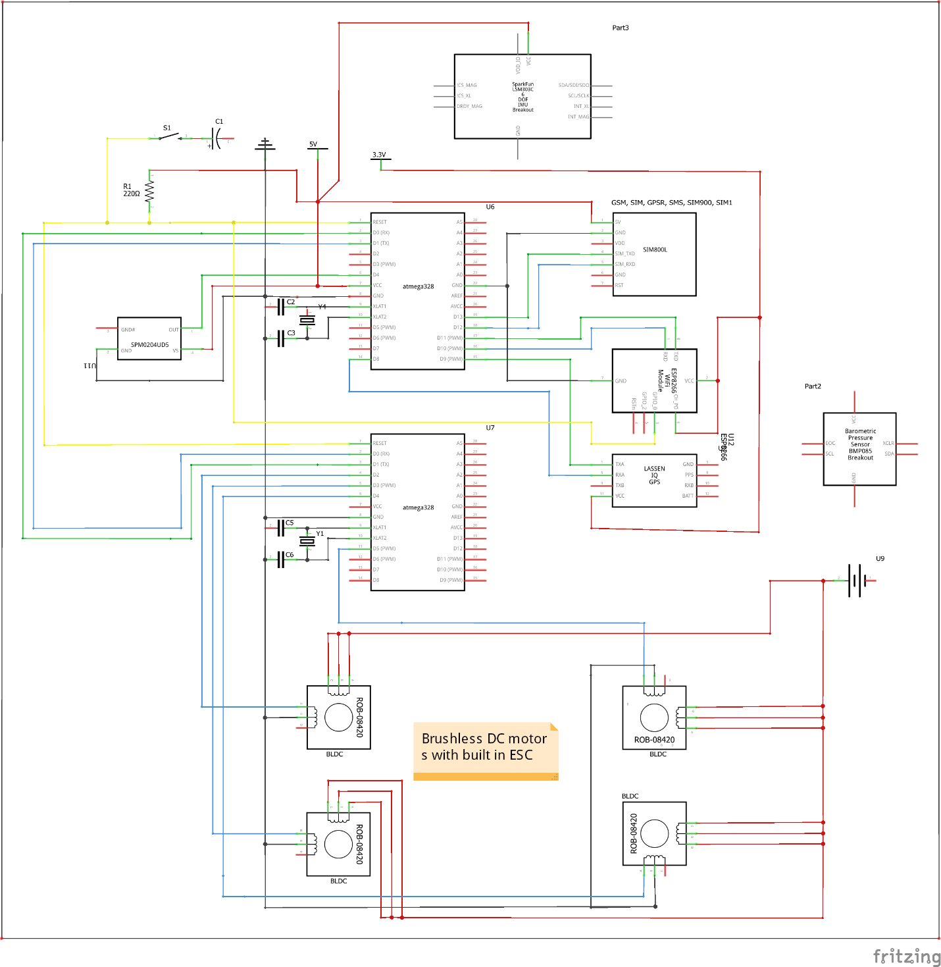

Figure 3 System circuit diagram

# DRONE BUILDING

After design the circuit and having done mathematical analysis of the circuit I started designing the circuit. I started with the frame, flight controller (control system) and communication systems of the drone.

The control system of the drone consists of two microcontrollers connected to each other by serial connection. The first microcontroller is connected to communication devices GSM and ESP8266 (WIFI) module, MPU6050 (Inertia Measurement Unit, IMU which contains both Gyroscope and Accelerometer), Ultrasonic distance sensor, Barometric Pressure sensor (BMP), and Compass/magnetometer.

## DRONE FRAME BUILDING

To make the frame, I needed the following materials and tools:

1. Wooden sealing board,
2. Bamboo sticks
3. Saw,
4. Hammer,
5. Rule and a pencil,
6. Bolts and nuts,
7. Araldite glue,
8. Glue gun,
9. Sol tape
10. Screws and screwdrivers

I used the rule to measure different length of the wooden sealing board and a pencil draw the cutting lines on the board and used the saw to cut the board into rectangular board of 13x23 cm.

A 13x23 cm rectangular board is the board that the electronic circuit and drone arms are mounted on.

Also I used three 23 cm bamboo sticks to make the chases for my drone. The sticks were connected by using glue from glue gun. On these sticks the 13x23 cm rectangular board will be mounted.

Also I used two 19 cm bamboo sticks to make the drone arms on which the brushless motors will be mounted on. The 19 cm drone arms were connected to the three 23 cm bamboo sticks by using glue from glue gun and sol tape.

On each end of the two 19 cm bamboo sticks a brushless motor was mounted on by using the 3D printed motor mounting.

Below the three connected 23 cm bamboo sticks I mounted the power distribution board and the drone battery.

On the front side of the drone the ultrasonic distance sensor was mounted.

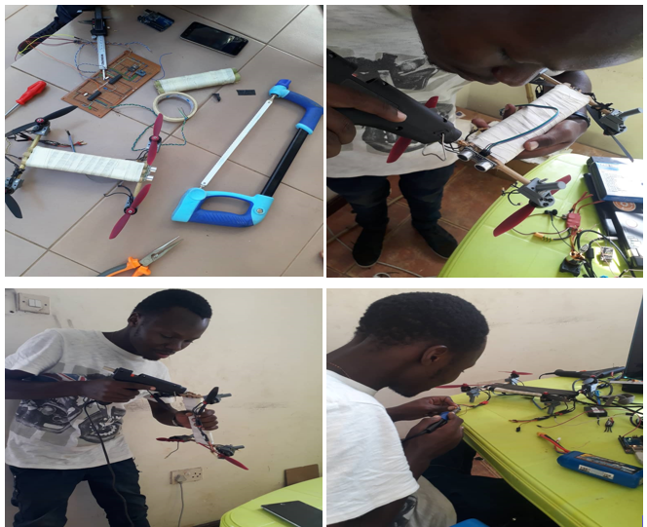

figure 4: Drone frame building

## DRONE FLIGHT CONROLLER CIRCUIT BUILDING

This involved soldering the electronic devices into the strip board and connecting them together with respect to the circuit designed.

To connect the communication devices and sensors to the first microcontroller I need the following tools:

1. Strip board,
2. Connecting wires,
3. Soldering gun and
4. Soldering wire,

The following are the devices to be soldered on the strip board or connected to the strip board using jumper wires are:

1. ESP8266 WIFI module
2. GSM/GPS module
3. MPU6050 (Inertia Measurement Unit, IMU),
4. Barometric pressure (BMP) sensor and
5. Two ATMega328P microcontrollers holders (chip holders)
6. Ultrasonic distance sensor.

### SOLDERING ATMega328P MICROCONTROLLER HOLDERS (CHIP HOLDERS)

The two microcontroller are not soldered directly to the strip board because it is needed to frequently remove them from the circuit for programming, so it is the chip holder that is soldered onto the strip board.

The two microcontrollers were connected by two serial ports. Two serial port were used to provide full duplex communication between the microcontrollers, the is one port for serial port transmission (Tx) and another for receiving (Rx). In the first microcontroller digital pin 5 and 6 were user and in the second microcontroller digital pin 0 and 1 were used for this communication.

For the two microcontrollers holders, on pin 7 and 8, a 5V Vcc and Ground was connected respectively. And on pin 9 and 10 and 16MHz crystal oscillator was connected respectively.

For the first microcontroller digital pin 0 and 1 are used for communication with a GSM/GPS module as Rx and Tx respectively and so were connected to. Digital pin 2 and 3 are used for communication with a ESP8266 WIFI module as Rx and Tx respectively and so were connected to. Digital pin 7 is used for sending pulse signal to Ultrasonic distance sensor so it was connected to trig pin of the sensor while digital pin 8 is used for listening echo signal from Ultrasonic distance sensor and so it was connected to echo pin of the sensor.

### SOLDERING MPU6050 (INERTIA MEASUREMENT UNIT, IMU) MODULE

The module was mounted on the strip board and soldered on it.

Serial Clock (SCL) and Serial Data (SDA) pin of the module were connected to analogue pin A5 and A4 of the first microcontroller respectively. SCL for sending control signals to the module from the microcontroller and SDA for receiving serial data from the module to the microcontroller. A 5V Vcc and Ground were connected to the module power pins (Vcc and GND respectively).

## DRONE COMMUNICATION SYSTEMS

### SOLDERING ESP8266 WIFI MODULE

The module was mounted on the strip board and soldered on it.

Tx and Rx pin of the module were connected to digital pin 2 and 3 of the first microcontroller respectively, for full duplex serial communications. A 3.3V Vcc and Ground were connected to the module power pins (Vcc and GND respectively).

Reset (RST) pin of the module was also connected to 3.3V to ensure that the chip is not reset when it is functioning.

### CONNECTING GSM/GPS MODULE

The module is not soldered on the strip board but screwed on 13x23 cm rectangular wooden sealing board using screw.

Tx and Rx pin of the module were connected to digital pin 0 and 1 of the first microcontroller respectively, for full duplex serial communications. A 5V Vcc and Ground were connected to the module power pins Vcc and GND respectively.

## DRONE SYSTEM POWER SUPPLY

The LIPo battery is used to supply power to the drone. I used the 4S LIPo battery which supply a maximum of 14.8V

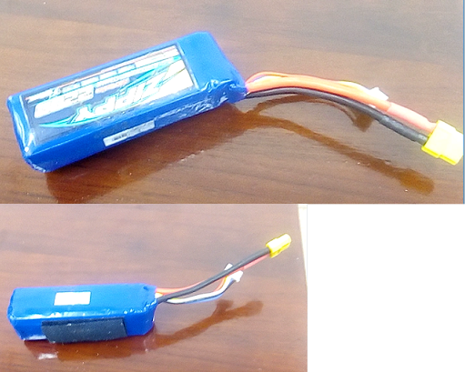

Figure 5: 4S LIPo battery

Microcontroller circuit is powered by 5V so it is needed a voltage regulator to regulate 14.8V to 5V.

ESP8266 WIFI module needs 3.3V also it needs a voltage regulator to regulate 5V to 3.3V. I used a 3.3 V zener diode to regulate 5V to 3.3V for the WIFI module.

Need was to calculate zener resistor (a series resistor to protect a zener diode).

Zener series resistor is the resistor connected is series with a zener diode to protect it from overheating and damaging of the diode by excessive current.

Zener diode specifications:

* Zener voltage (Vz) : 3.3V
* Power dissipation (Pz) : 500mW
* Zener current: 76mA

Zener series resistor is calculated as follows

Rs = (Vs – Vz) / Iz

Where Rs = Zener series resistor

Vs = supply voltage

Vz = Zener voltage (3.3V)

Iz = Maximum current the diode can a pass at a rate power dissipation.

Rs = (5 – 3.3) / Iz

Iz = Pz / Vz = 500mW / 3.3v = 151Ma

Then Rs = (5 – 3.3) / 151m = 11.25 ohm

Rs = 15 ohm (approximately)

## 

## MICROCONTROLLER SKETCH BUILDING

For the connect sensors and devices I made two sketch which I uploaded them to the microcontroller to test if and how my circuit works.

I made the Arduino sketch using Arduino IDE. The sketch used the following Arduino Libraries

1. SoftwareSerial library,
2. MPU6050_tochn library,
3. Wire library and
4. Servo library

SoftwareSerial library is for defining and enabling serial communication on ATMega328P digital pins. I used it because by default only digital pin 0 and 1 of the ATMega328P are enabled with serial communication capabilities.

MPU6050_tochn library is used for controlling my MPU6050 Module. The library contains functions/methods to get orientation of the drone in all the planes and linear speed of the drone in both three axes (X, Y, Z axis).

Wire library is used to provide the require clock signal to the analogue pins were the MPU6050 module is connected.

Using the sketch, I tested all the sensors and devices connected and see how they perform.

## ADROID APPLICATION DEVELOPMENT

I have developed an android application that is used to send commands to the drone and to check drone system status.

Current the application can only start, stop the drone and display the drone status.

An application displays the following drone statuses:

1. WIFI Module status
2. GSM Module status
3. MPU6050 module status
4. Drone battery status
5. Drone motor ON or OFF status and
6. Current GPS location of drone

So I built an android application with only one activity containing 4 fragments, one fragment for sending command to the drone, another for viewing drone status. Two other fragments are not yet implemented.

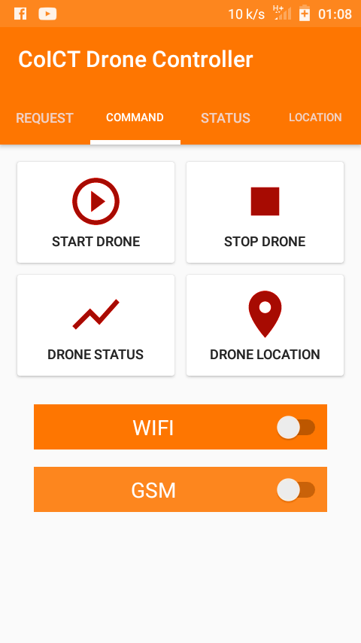

Figure 6: FRAGMENT 2 FOR SENDING COMMANDS TO THE DRONE

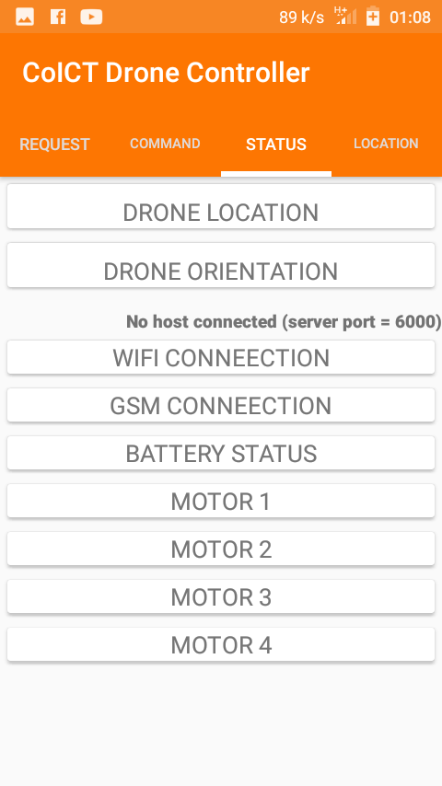

Figure 7: FRAGMENT 3 FOR VIEWING DRONE STATUS

# WORKDONE SO FAR

* I have consulted supervisor.
* I have consulted drone building expert.
* I have built the drone frame.

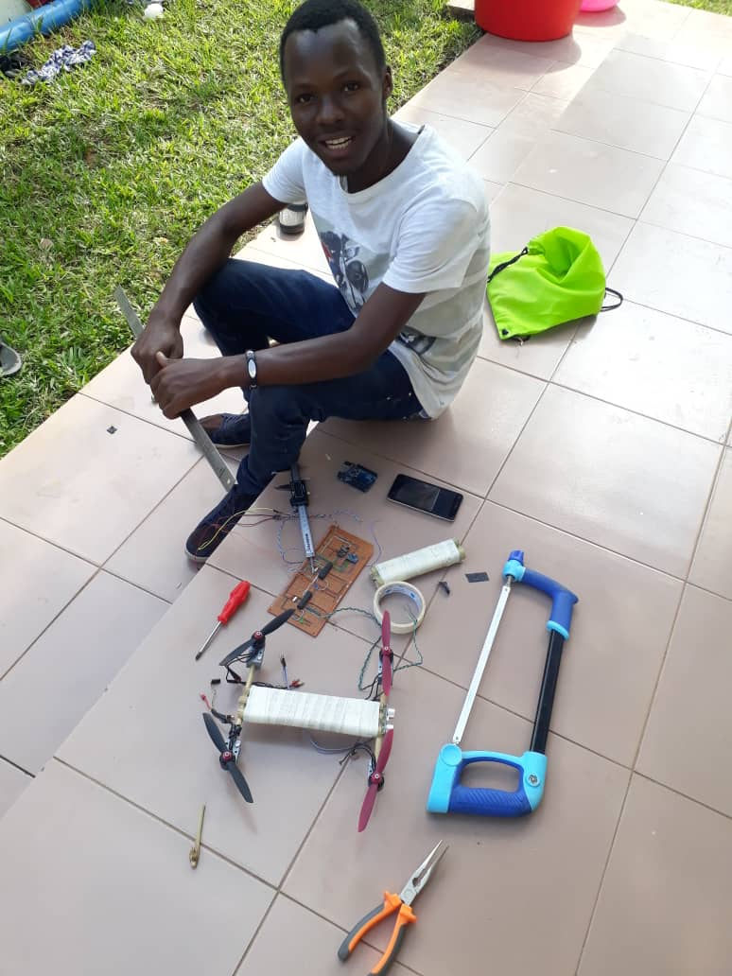

* I have built the drone control circuit and soldered it on the strip board.

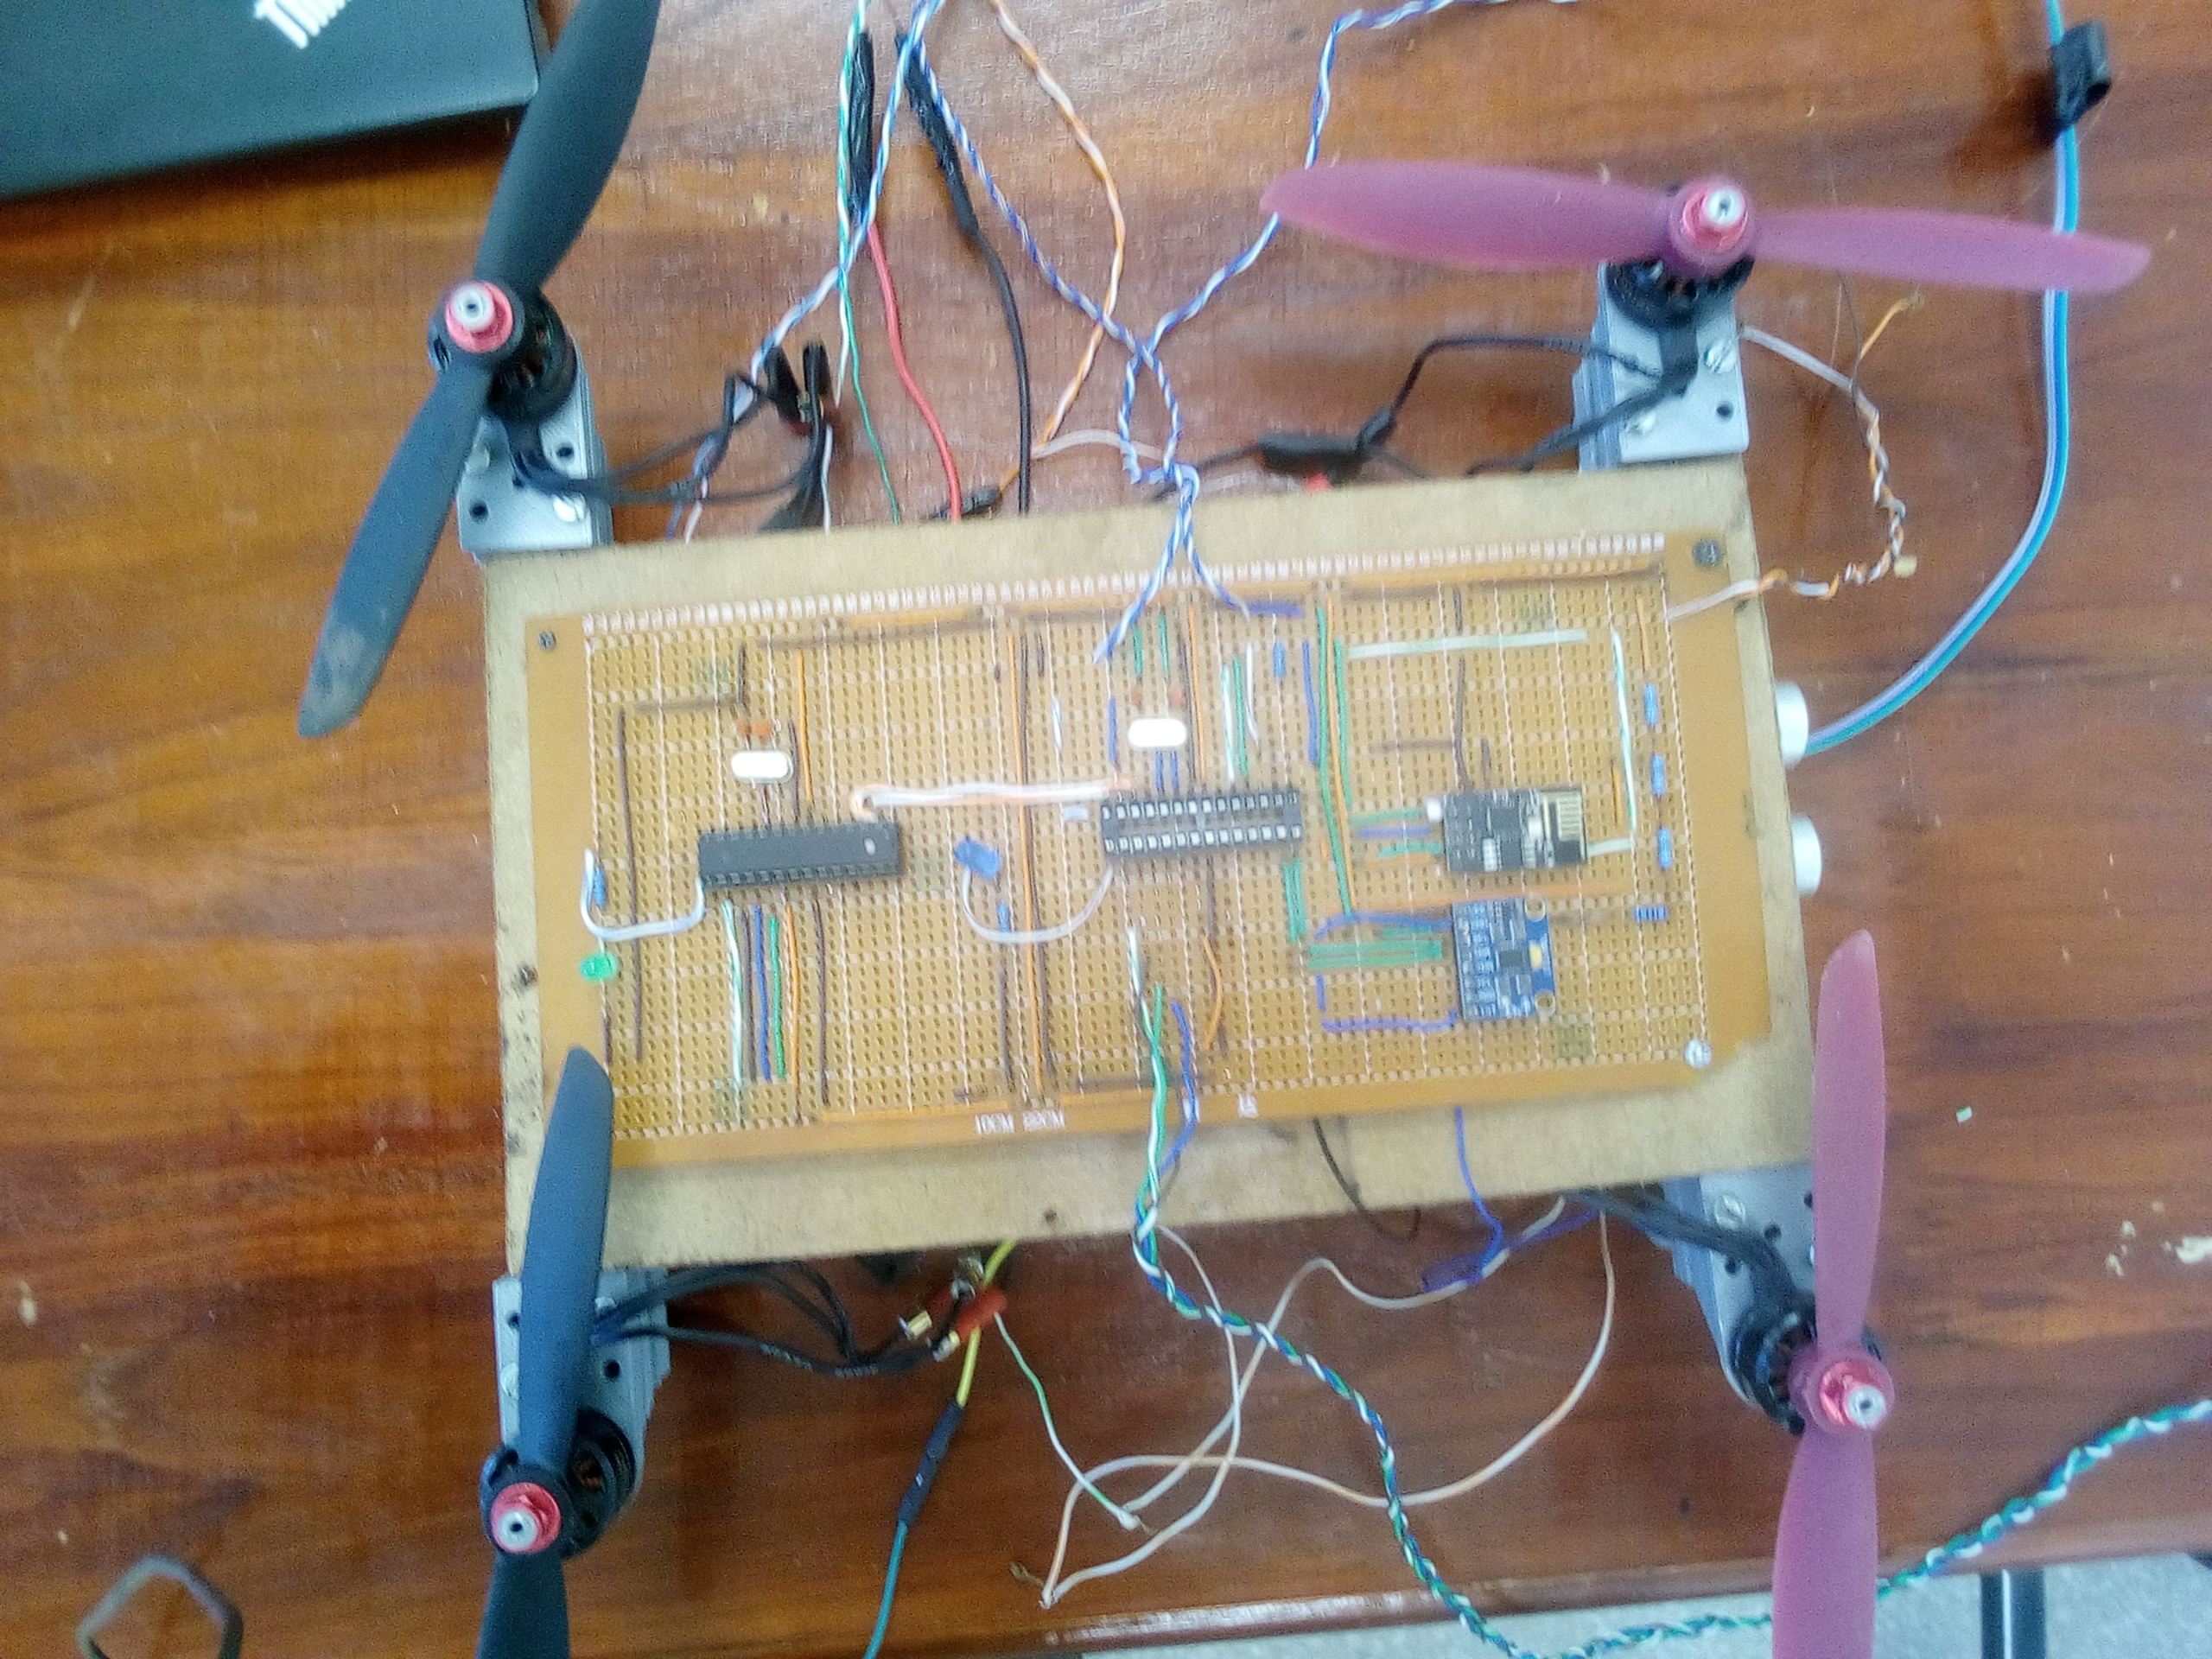

Figure 8: drone control circuit

* I have mounted the motors, propellers and the soldered strip board on the drone frame.

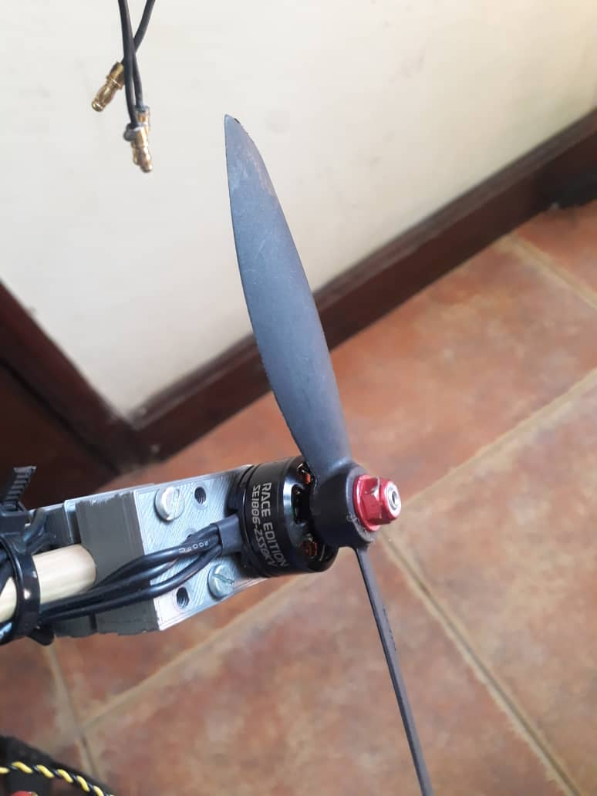

Figure 9: brushless motor with propellers

* I have made the control sketches for the two microcontrollers.

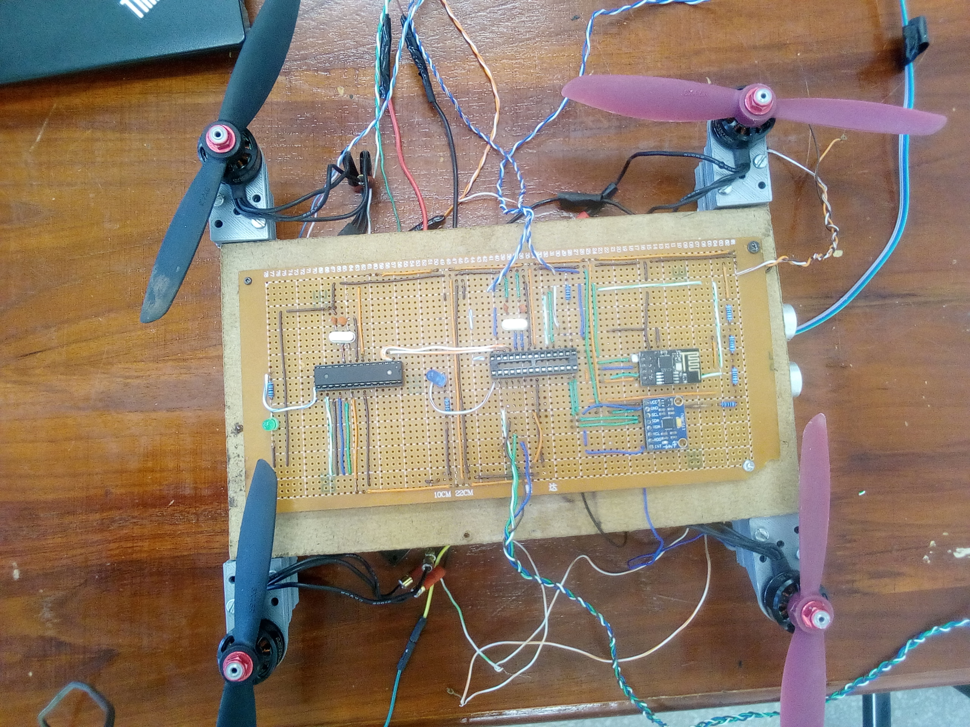

* I have developed an android application.
* I have linked the android application with the drone using WIFI and GSM communications.

# SUMMARY

* I have to test the propulsion system of the drone: this involves calibrating the force generates by motors at different speed so that I can know how much motors’ speed it need for the drone to fly and move in different directions.
* I have to finish linking the android application to the drone.
* I have to test the drone system.

# TIME SCHEDULE

|  |  |
| --- | --- |
| S/N | ACTIVITY |
| 1 | 2 | 3 | 4 | 5 | 6 | 7 | 8 | 9 | 10 | 11 | 12 | 13 | 14 | 15 |
| 1 | Supervisor and drone Experts consultation |  |  |  |  |  |  |  |  |  |  |  |  |  |  |  |
| 2 | Literature review |  |  |  |  |  |  |  |  |  |  |  |  |  |  |  |
| 3 | Circuit building |  |  |  |  |  |  |  |  |  |  |  |  |  |  |  |
| 4 | Android application development |  |  |  |  |  |  |  |  |  |  |  |  |  |  |  |
| 5 | Progressive report writing |  |  |  |  |  |  |  |  |  |  |  |  |  |  |  |
| 6 | Progressive report submission |  |  |  |  |  |  |  |  |  |  |  |  |  |  |  |
| 7 | Oral presentation of the project |  |  |  |  |  |  |  |  |  |  |  |  |  |  |  |
| 8 | Final progressive report writing |  |  |  |  |  |  |  |  |  |  |  |  |  |  |  |
| 8 | Final progressive report submission |  |  |  |  |  |  |  |  |  |  |  |  |  |  |  |
| 10 | Final oral presentation of the project |  |  |  |  |  |  |  |  |  |  |  |  |  |  |  |
| 11 | System demonstration and submission |  |  |  |  |  |  |  |  |  |  |  |  |  |  |  |

Table 4: Project time schedule

# BUDGET

|  |  |  |
| --- | --- | --- |
| **S/N** | **DEVICE** | **COST ($)** |
| **1** | **Microcontroller (x1)** | **10.8/=** |
| **2** | **Drone motors (x4)** | **192/=** |
| **3** | **Electric speed controller** | **56/=** |
| **3** | **Drone battery** | **101.28/=** |
| **4** | **Drone propellers** | **58/=** |
| **5** | **GSM Module** | **10.8/=** |
| **6** | **GPS Module** | **10.8/=** |
| **7** | **WIFI Module** | **4.32/=** |
| **Total** | | **444/=** |

Table 5: Project budget

# CONCLUSION, CHALLENGE AND RECOMMENDATION

The drone can fly from one place to another and can carry a load of 0.5 Kg.



## Conclusion

The objective of the project was to design and implement A CoICT drone. The drone can be used to carry material from one place to another within the campus.

## Challenges

The major challenges occurred during accomplishment of this project were as follows:

* Lack of enough knowledge on various stage of the project, this challenge was solved through literature reviews.
* I was hard to get the need electronic equipment’s which it cost me to buy them from abroad.

## Recommendations

The scope of the project can be further expanded to be used to carry medicines from one hospital to another. Also the drone can be used for business purposes, to delivery products from sellers to their customers.

# REFERENCES

1. International Journal of Geo-Information, by ISPRS 2018
2. <https://www.amazon.com/Build-Drone-Step-Step-Constructing/dp/1510707050> on ${01}^{th}$ January 2019
3. <http://www.dummies.com/consumer-electronics/drones> on ${22}^{th}$ January 2019
4. <http://www.dummies.com/consumer-electronics/drones/popular-uses-for-drone> on ${10}^{th}$ January 2019
5. <http://www.acoptext.com> on $2^{th}$ January 2019
6. <http://www.instructables.com> on $2^{th}$ January 2019
7. <http://www.youtube.com/amaizing_power_of_drones> on ${12}^{th}$ January 2019
8. UDSM CoICT report writing guideline 2018